Crossword Puzzle

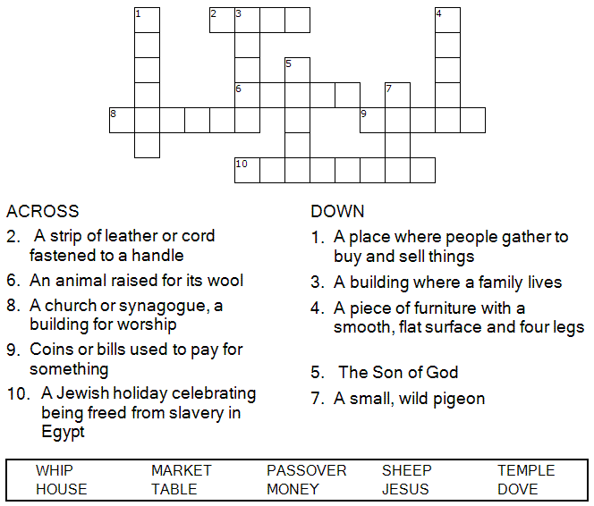

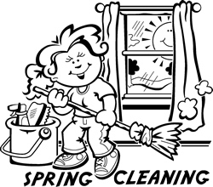
Copyright © Sermons4Kids, Inc.
May be reproduced for Ministry Use

Children’s Worship Bulletin



John 2:13-16

Word Search Puzzle

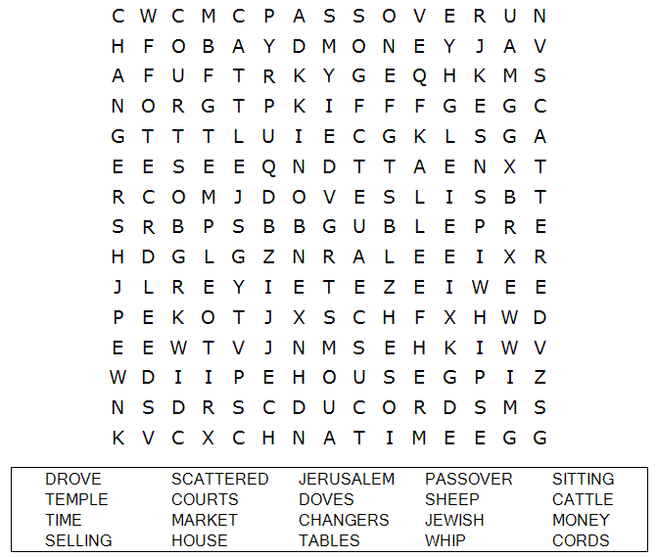

Your Church Name Here
Anytown, Anywhere

Coloring Page

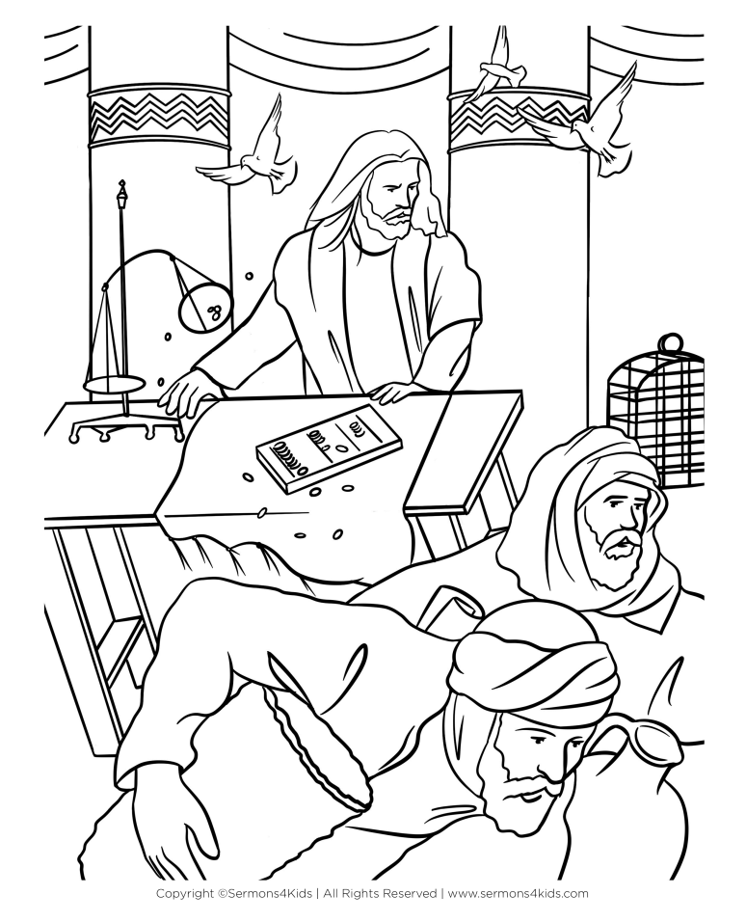
Jesus Cleansing the Temple

Multiple Choice

Choose the word that best matches the definition.
Check your answers in John 2:13-16 (NIV)

