Crossword Puzzle

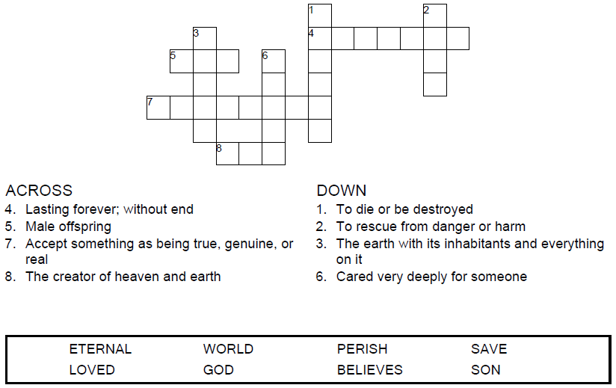

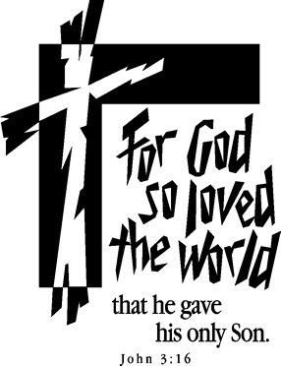

Copyright © Sermons4Kids, Inc.
May be reproduced for Ministry Use

Children’s Worship Bulletin



John 3:16

Word Search Puzzle

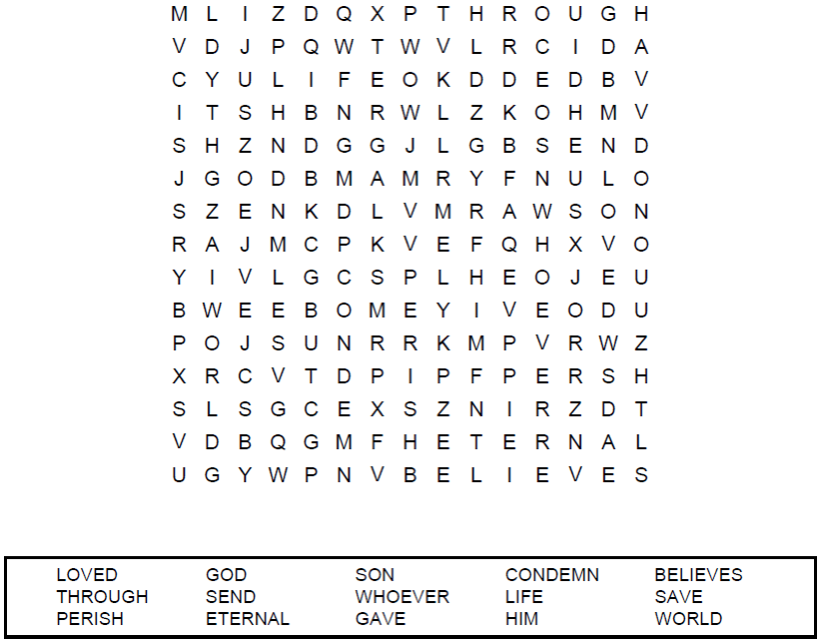

Your Church Name
Church Address
Any town, Anywhere

Decoder Puzzle
Each number represents a letter of the alphabet.
Substitute the correct letter for the numbers to
reveal the coded words.

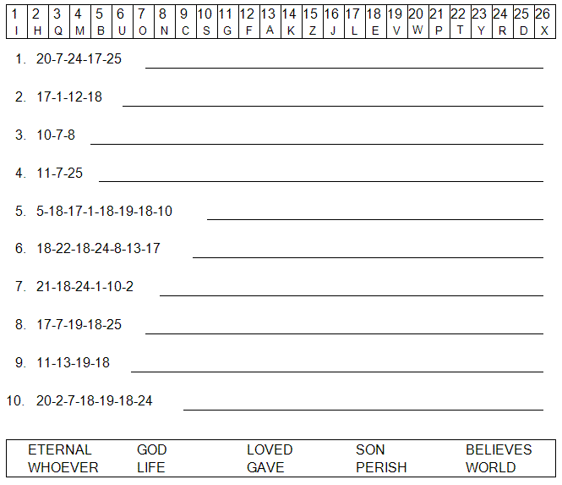



Coloring Page



