Crossword Puzzle

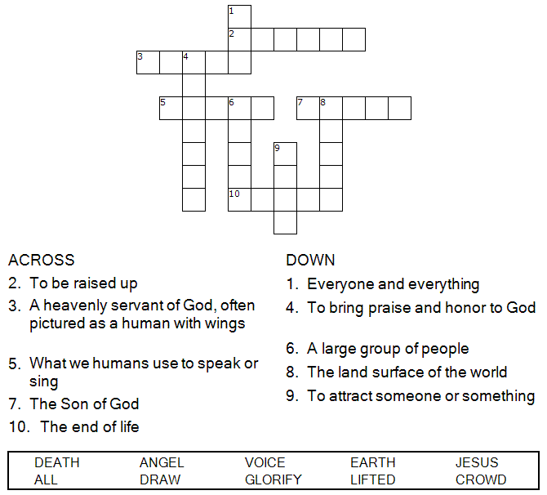


Copyright © Sermons4Kids, Inc.
May be reproduced for Ministry Use

Children’s Worship Bulletin



John 12:28-33

Word Search Puzzle

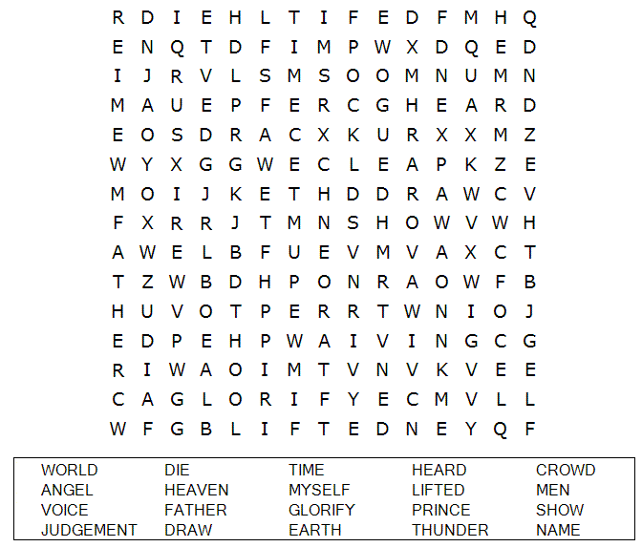
Your Church Name Here
Anytown, USA

Coloring Page

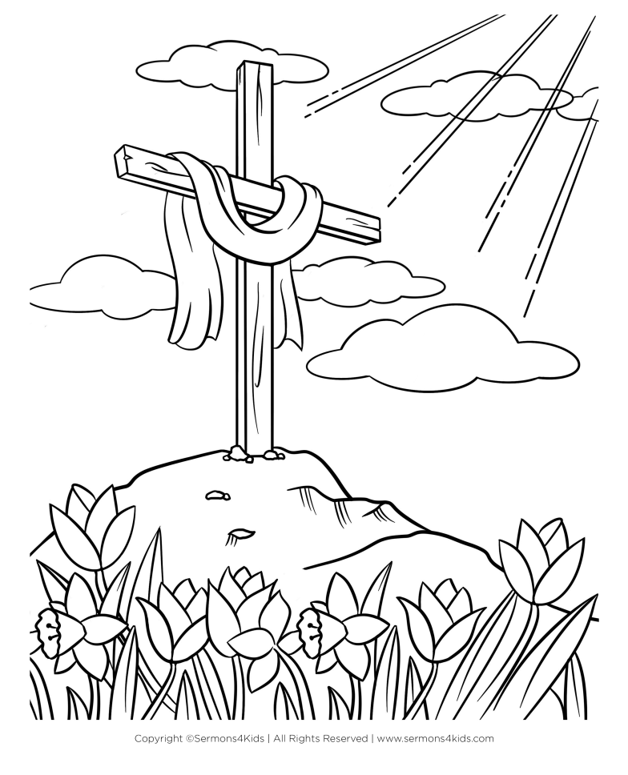

“And I, when I am lifted up from the earth,
will draw all people to myself.”
John 12:32

Multiple Choice

Choose the word that best matches the definition.
Check your answers in John 12:28-33 (NIV)

