Crossword Puzzle

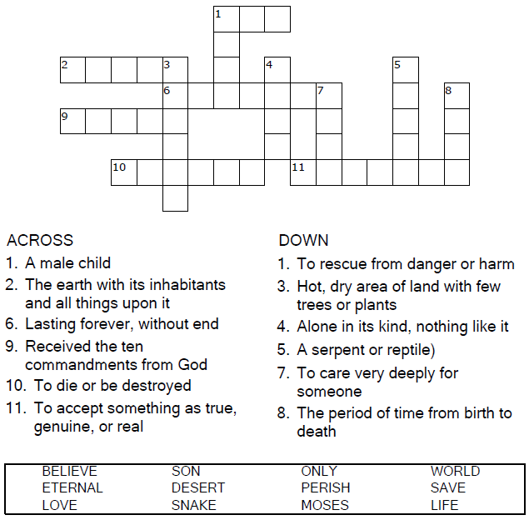

Copyright © Sermons4Kids, Inc.
May be reproduced for Ministry Use

Children’s Worship Bulletin



John 3:14-17

Word Search Puzzle

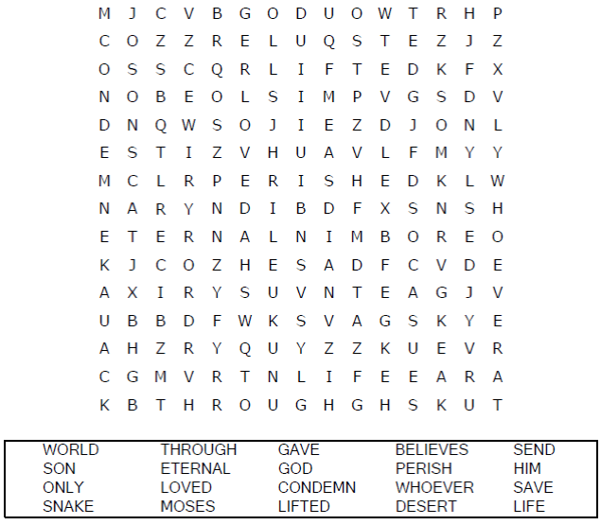
Your Church Name Here
Anytown, Anywhere

Coloring Page

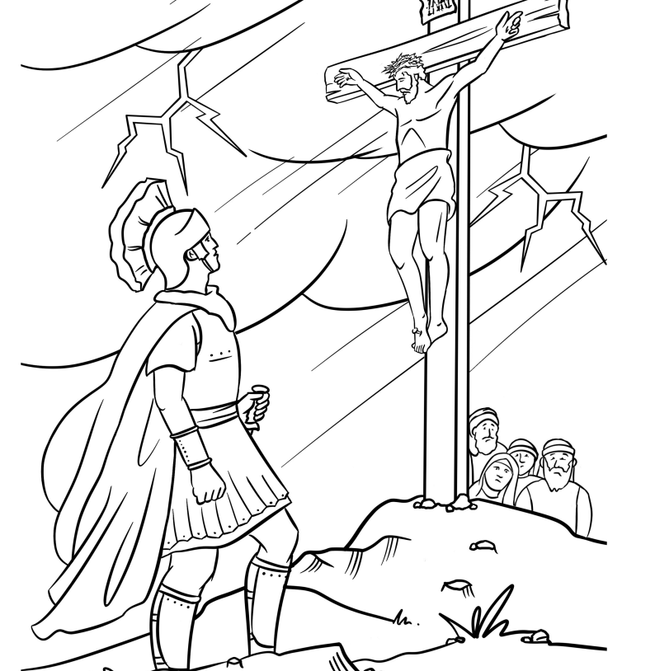


For God so loved the world that he gave his one and
only Son, that whoever believes in him shall not
perish but have eternal life.
John 3:16 (NIV)

Decoder Puzzle

