Crossword Puzzle

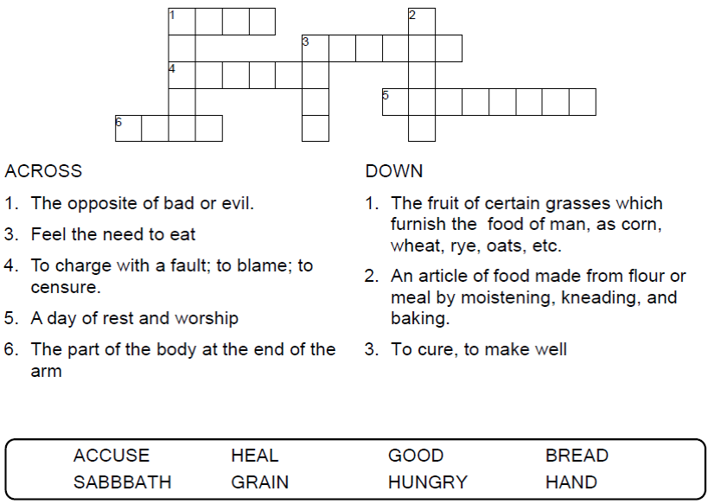
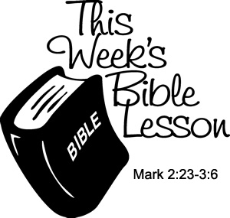

Copyright © Sermons4Kids, Inc.
May be reproduced for Ministry Use

Children’s Worship Bulletin

The Lord of the Sabbath

Mark 2:23-3:6

Word Search Puzzle

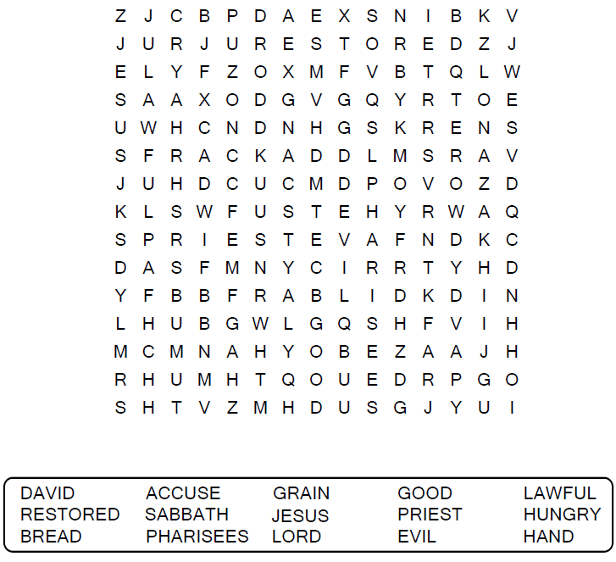
Your Church Name
Any Town, Anywhere

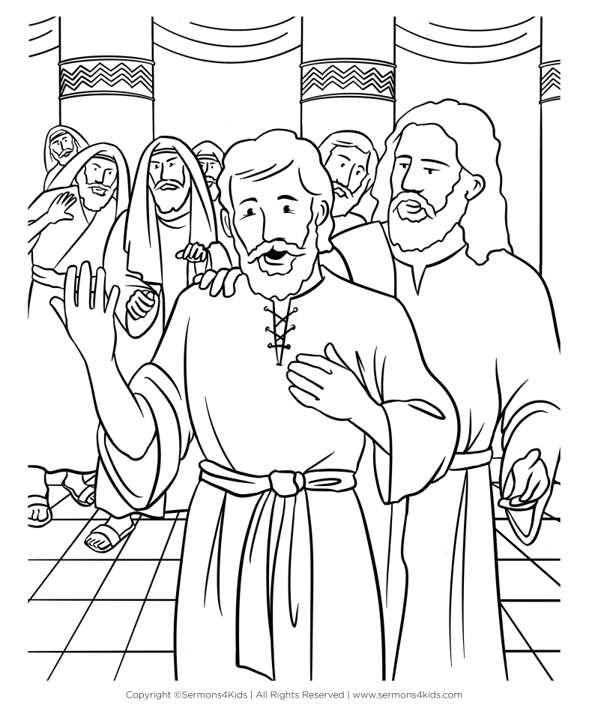

Coloring Page

Jesus Heals a Withered Hand
Mark 3:1-6

Decoder Puzzle

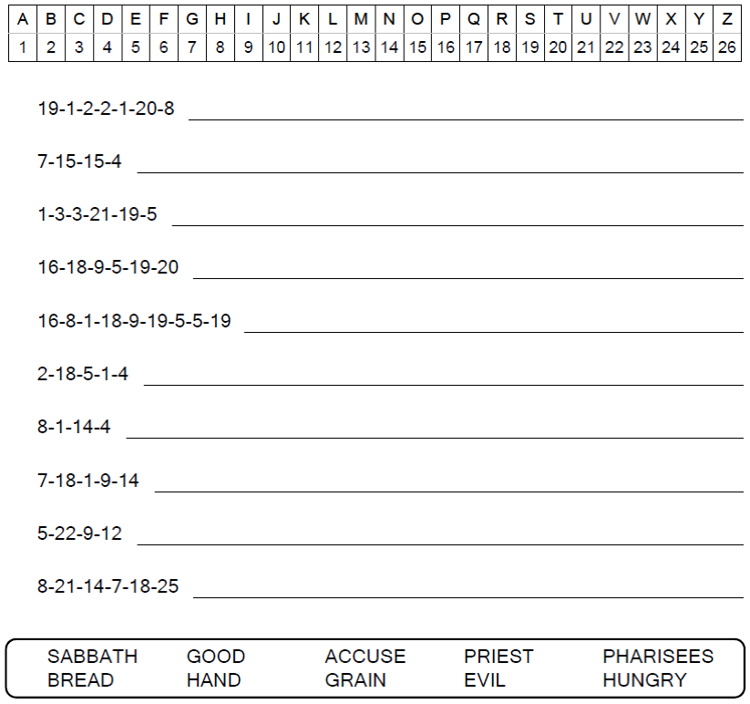

Then Jesus asked them, “Which is lawful on the Sabbath:
to do good or to do evil, to save life or to kill?”
But they remained silent.
Mark 3:4 (NIV)

