Crossword Puzzle

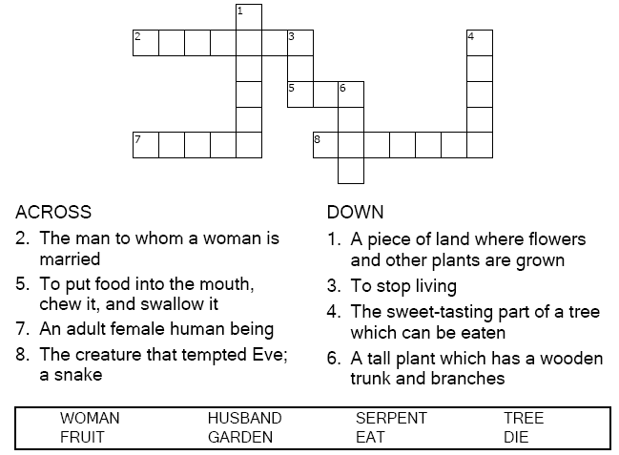

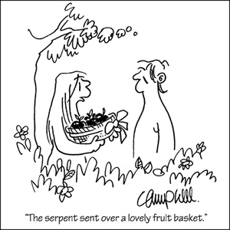

Copyright © Sermons4Kids, Inc.
May be reproduced for Ministry Use
Children’s Worship Bulletin



Genesis 2:15-17; 3:1-7

Word Search Puzzle

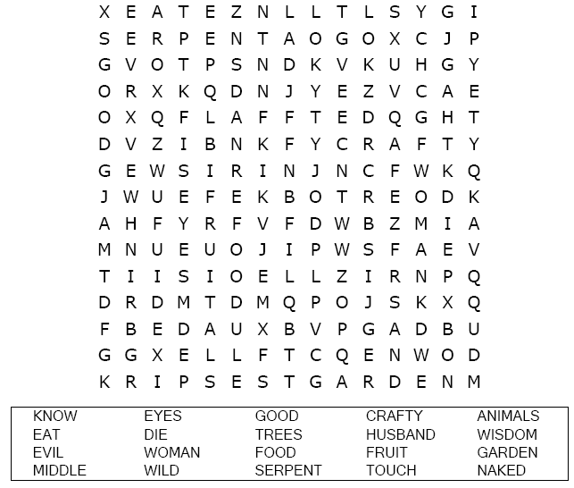
Your Church Name
Address

Coloring Page

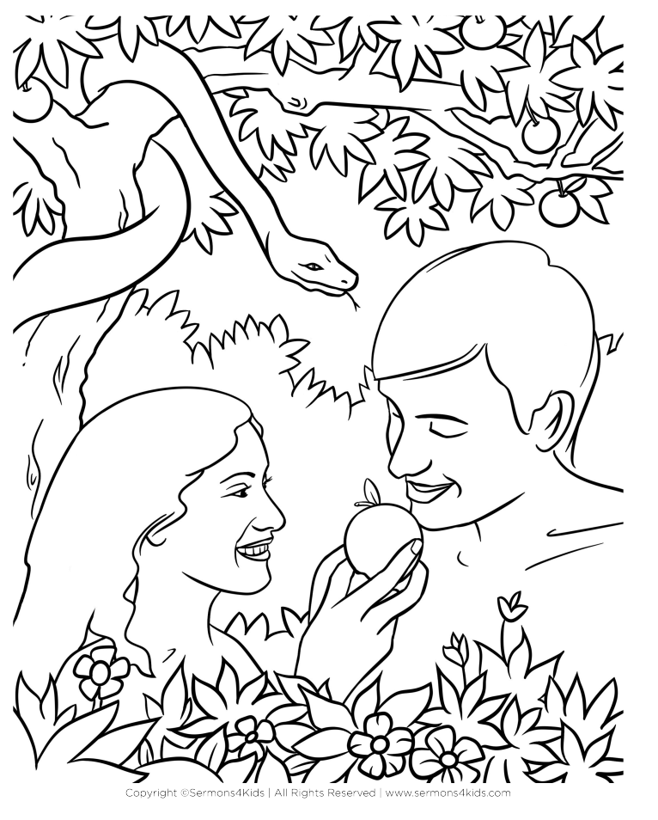
"But God did say, 'You must not eat fruit from the
tree that is in the middle of the garden.' "
Genesis 3:3

Multiple Choice

Choose the word that best matches the definition.

