Crossword Puzzle

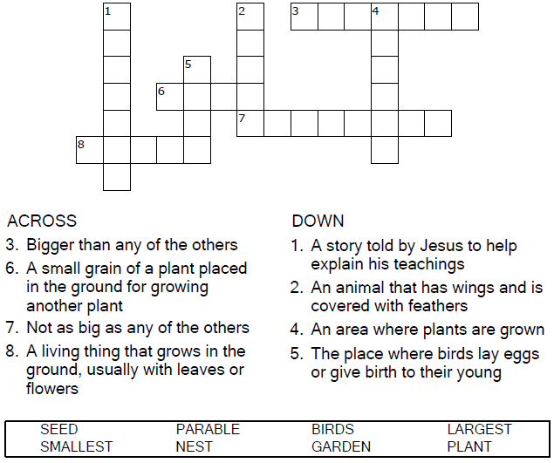


Copyright © Sermons4Kids, Inc.
May be reproduced for Ministry Use
Children’s Worship Bulletin



Mark 4:30-34

Word Search Puzzle

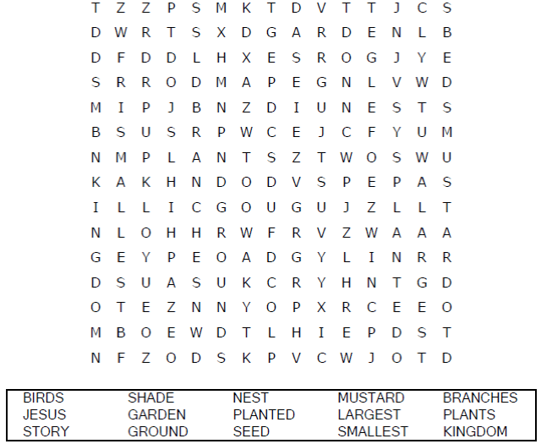
Your Church Name
Any Town, Anywhere
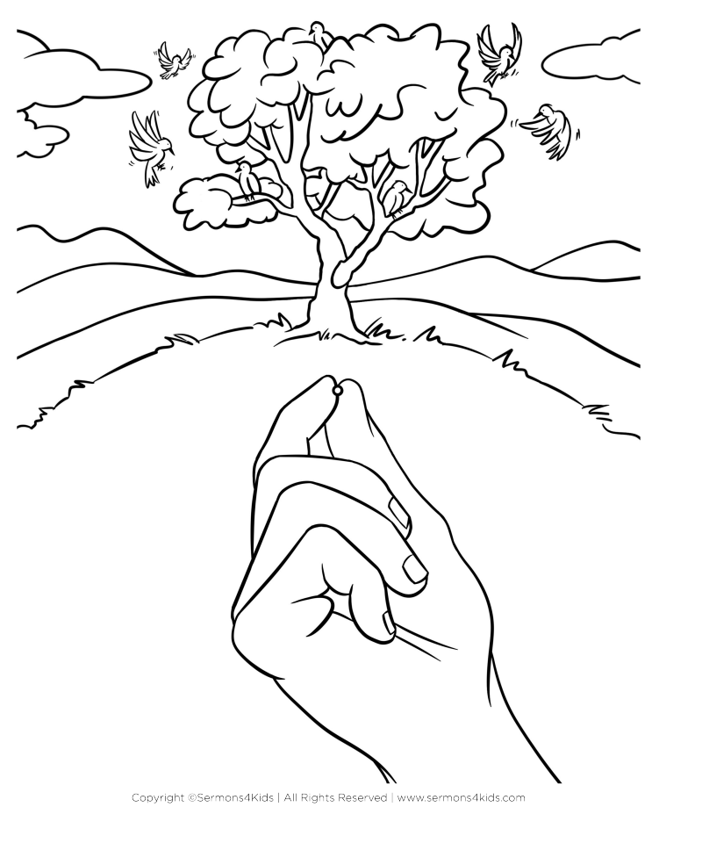

Coloring Page

The Parable of the Mustard Seed
Again he said, “What shall we say the kingdom of God
is like, or what parable shall we use to describe it? It is
like a mustard seed, which is the smallest of all seeds
on earth. Yet when planted, it grows and becomes the
largest of all garden plants, with such big branches
that the birds can perch in its shade.”
Mark 4:30-32 (NIV)

Decoder Puzzle

