Crossword Puzzle

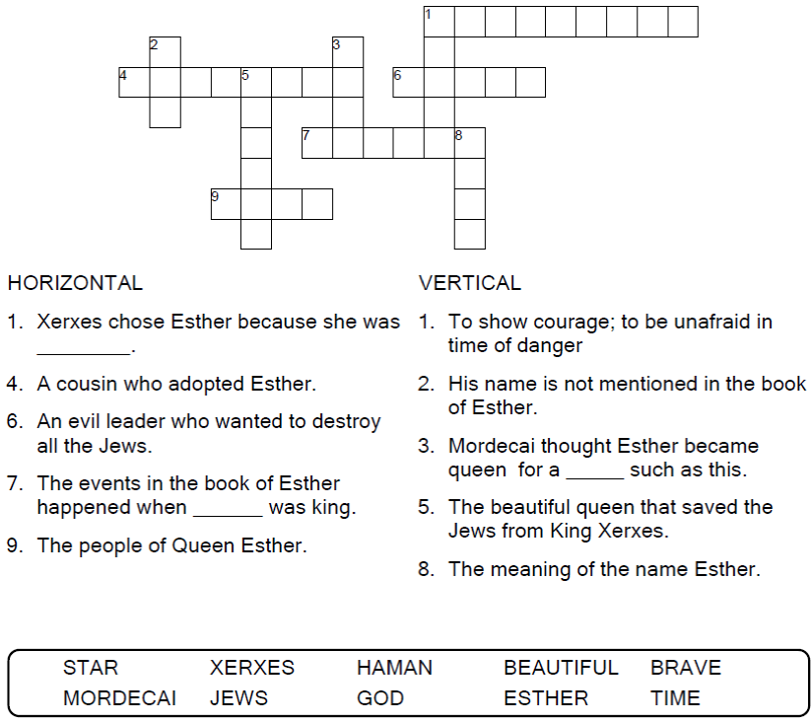

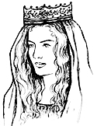

Copyright © Sermons4Kids, Inc.
May be reproduced for Ministry Use

Children’s Worship Bulletin



Esther 1:1-4:1-17

Word Search Puzzle

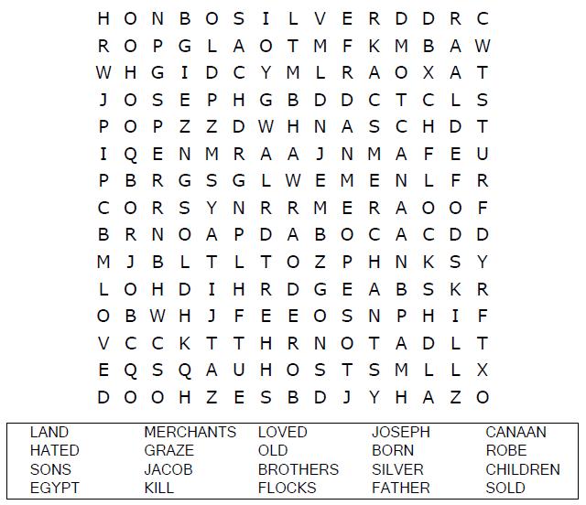
Church Name
Address
City

Coloring Page
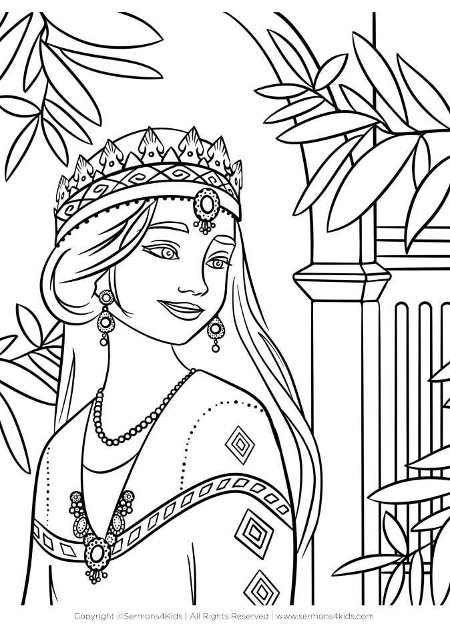

Decoder Puzzle

Each number represents a letter of the alphabet.
Substitute the correct letter for the numbers to
reveal the coded words.

