Crossword Puzzle

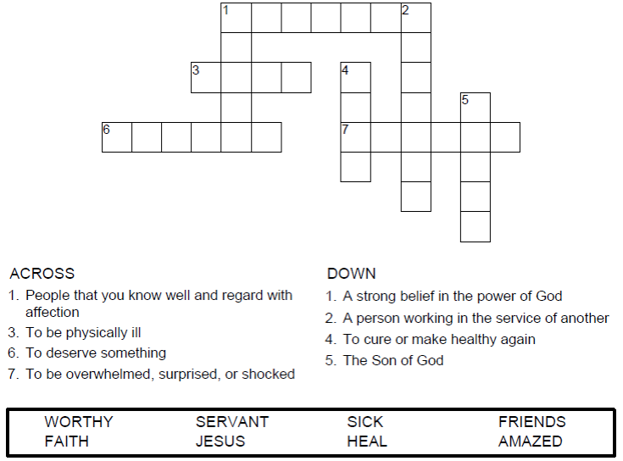


Copyright © Sermons4Kids, Inc.
May be reproduced for Ministry Use
Children’s Worship Bulletin



Luke 7:1-10

Word Search Puzzle

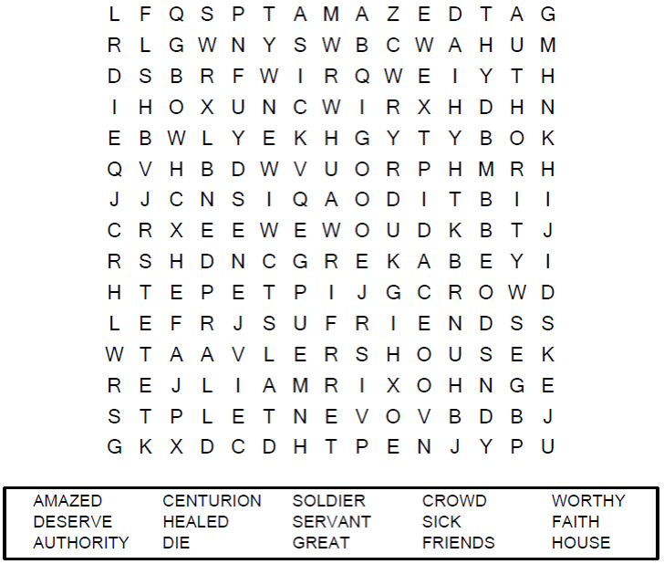
Your Church Name
Any Town, Anywhere

Coloring Page

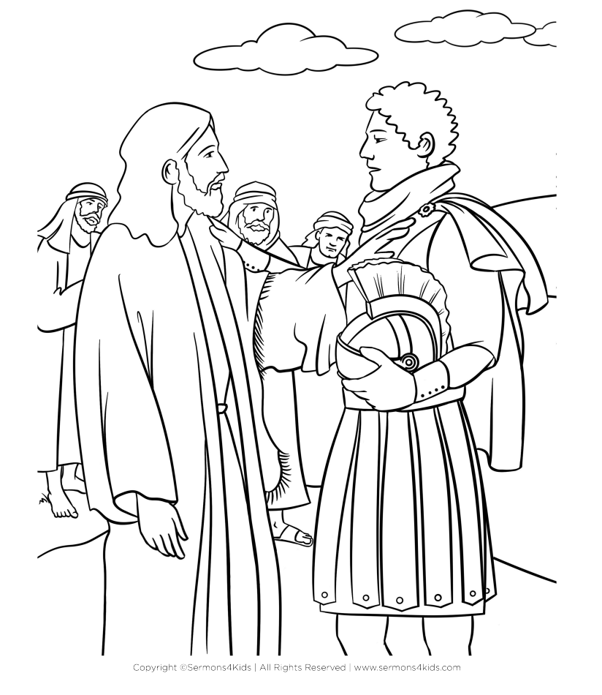

The Healing of the Centurion’s Servant

Decoder Puzzle
Each number represents a letter of the alphabet. Substitute the
correct letter for the numbers to reveal the coded words.

