Crossword Puzzle

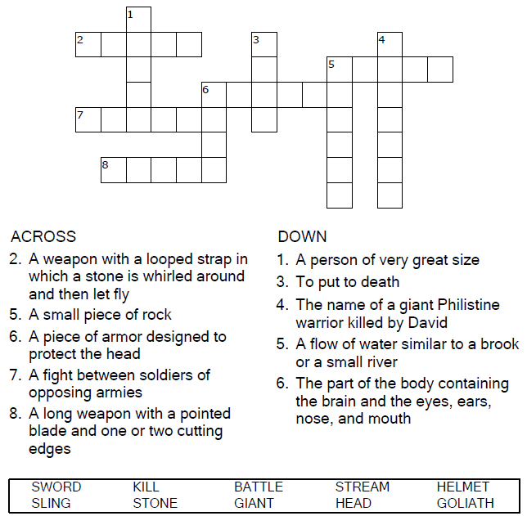
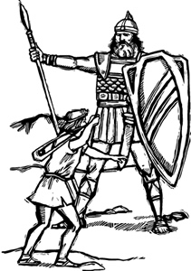

Copyright © Sermons4Kids, Inc.
May be reproduced for Ministry Use
Children’s Worship Bulletin



1 Samuel 17:32-49

Word Search Puzzle

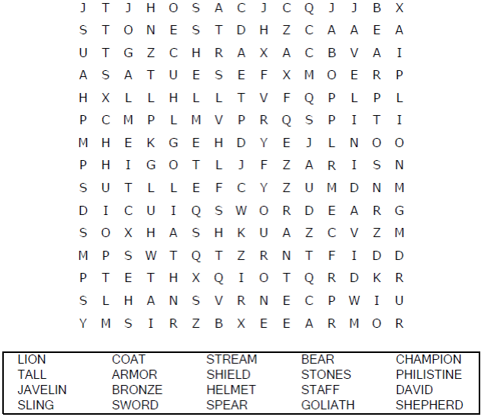
Your Church Name
Any Town, Anywhere

Coloring Page

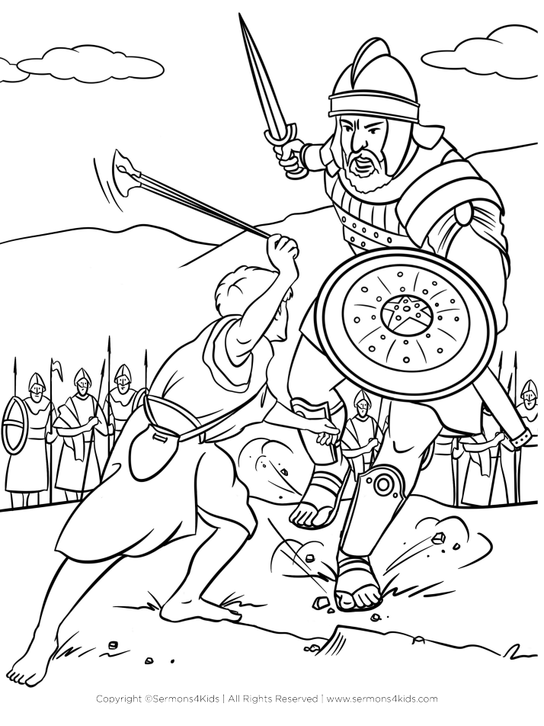
David & Goliath
1 Samuel 17:32-49

Decoder Puzzle

Each number represents a letter of the alphabet. Substitute
the correct letter for the numbers to reveal the coded words.

