Crossword Puzzle

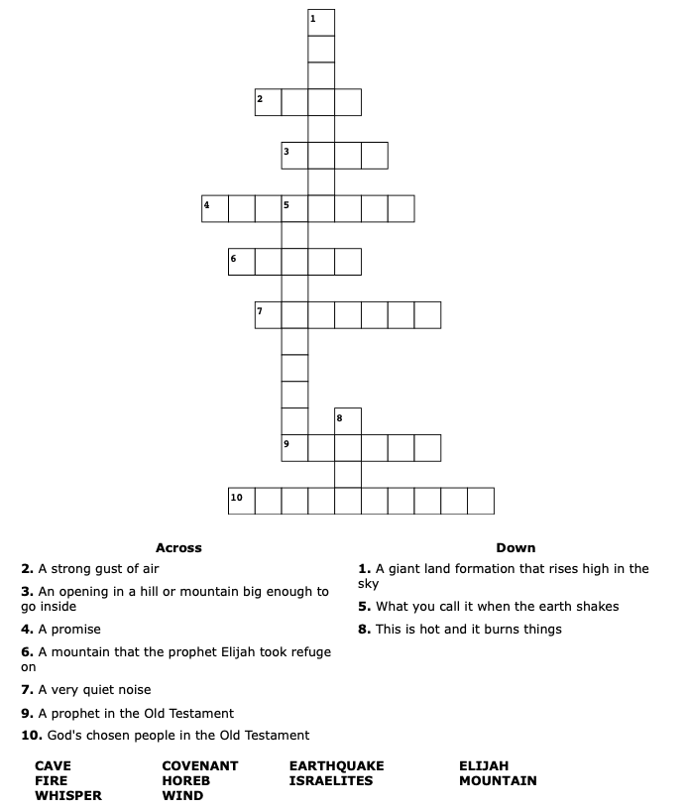

Copyright © Sermons4Kids, Inc.
May be reproduced for Ministry Use
Children’s Worship Bulletin

The Lord Appears to Elijah

1 Kings 19:9-18

Word Search Puzzle

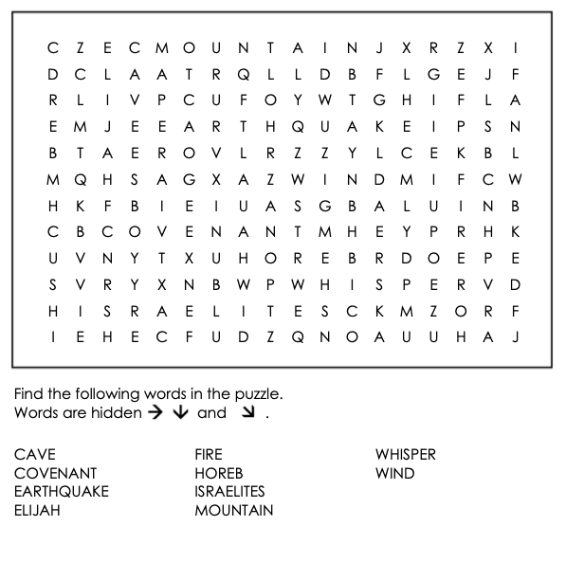

Your Church Name Here
Address

Maze

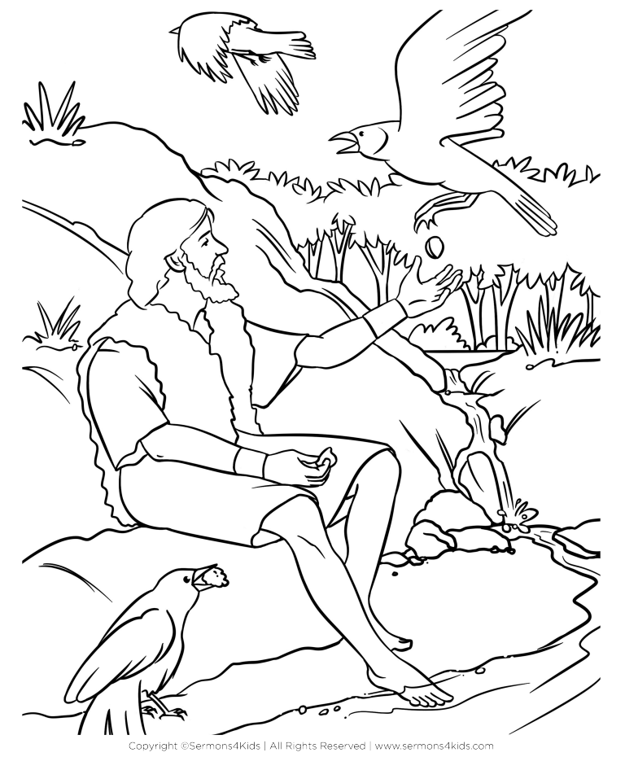


Coloring Page

