Crossword Puzzle

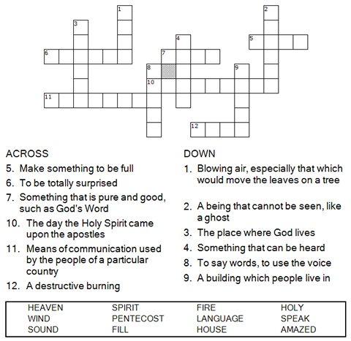



Copyright © Sermons4Kids, Inc.
May be reproduced for Ministry Use

Children’s Worship Bulletin



Acts 2:1-21

Word Search Puzzle

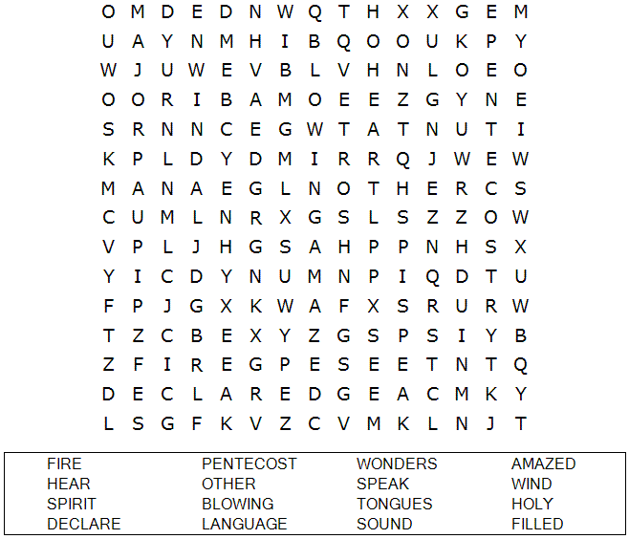

Your Church Name Here
Anytown, USA

Coloring Page

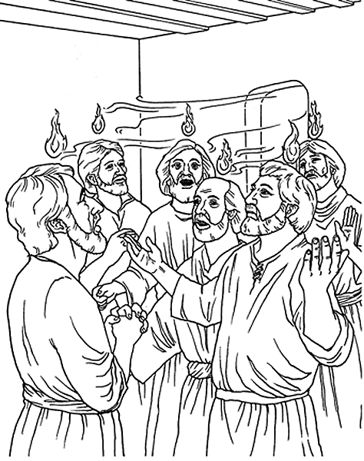
The Day of Pentecost

From BibleStoryCard Learning System™ Coloring Book © 1996 Wesleyan Publishing House Used by permission. Additional BibleStoryCard resources available by visiting online
http://www.wphonline.com/

Word Jumble
Unscramble each word and then place the numbered letters
in the numbered boxes at the bottom to reveal the answer.

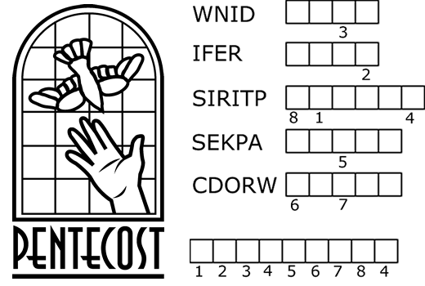

PUZZLE CLUES
1. A sound like the blowing of a violent _______ came from heaven.
2. They saw what seemed to be tongues of ______.
3. All of them were filled with the Holy _______.
4. They began to ______ in other tongues as the Spirit enabled them.
5. Peter stood up and spoke to the ______ of people.
Answer: All of these events took place on the day of _____________.
Check your answers in Acts 2:1-14 (NIV)

