Crossword Puzzle

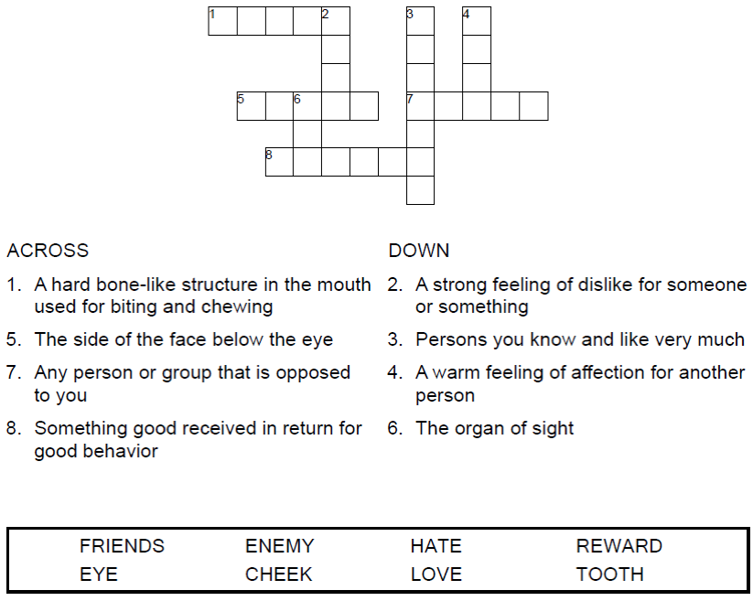



Copyright © Sermons4Kids, Inc.
May be reproduced for Ministry Use

Children’s Worship Bulletin



Matthew 5:38-48

Word Search Puzzle

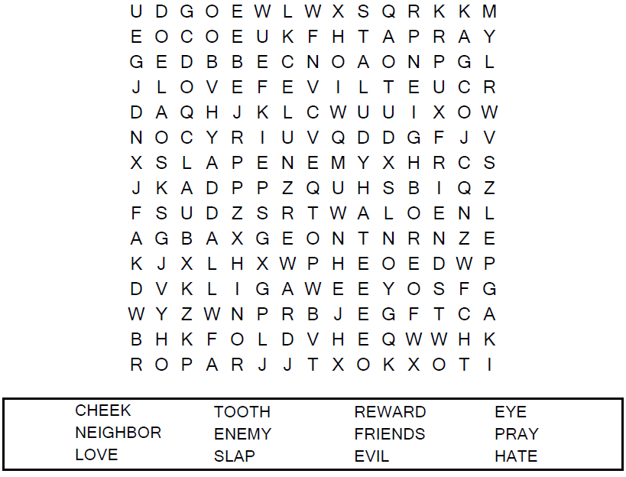

Your Church Name Here
Anytown, Anywhere

Coloring Page

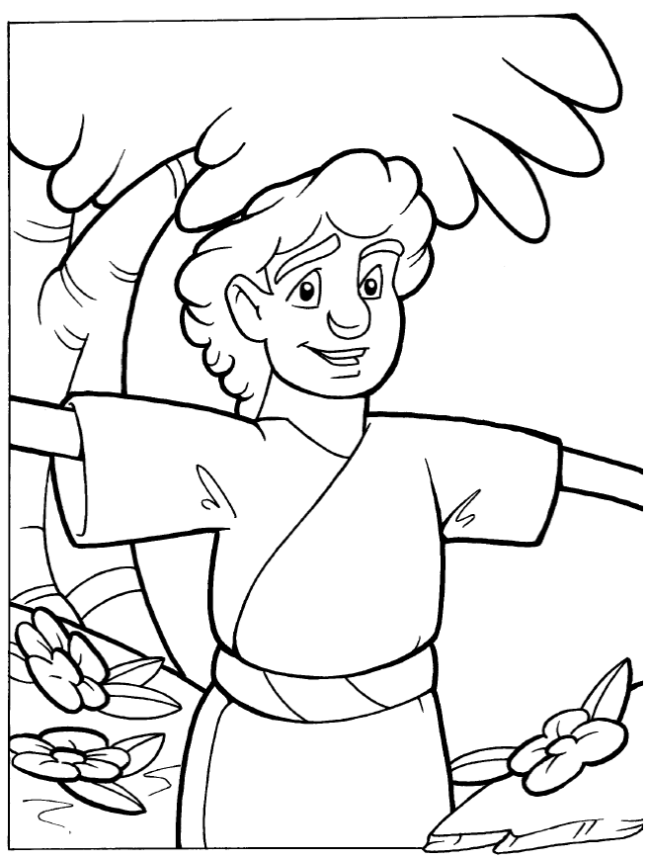
“But I say, love your enemies! Pray for those who persecute you!”
Matthew 5:44

Decoder Puzzle
Each number represents a letter of the alphabet. Substitute
the correct letter for the numbers to reveal the coded words.
