Crossword Puzzle

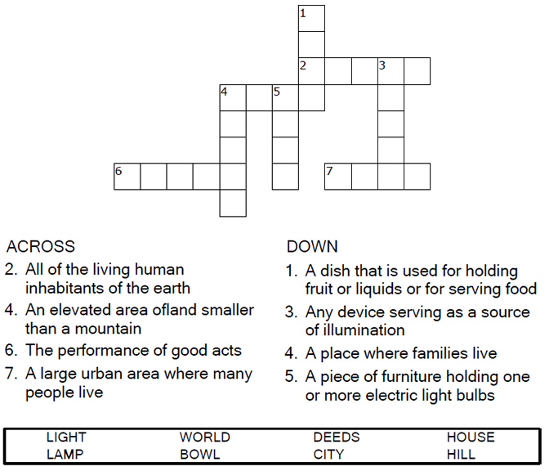

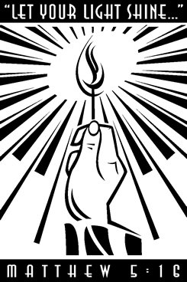

Copyright © Sermons4Kids, Inc.
May be reproduced for Ministry Use

Children’s Worship Bulletin



Matthew 5:14-16

Word Search

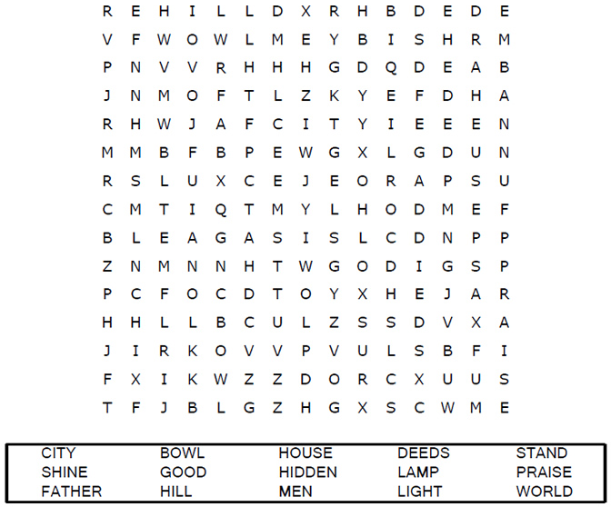
Your Church Name
City or Town

Decoder Puzzle
Each number represents a letter of the alphabet. Substitute
the correct letter for the numbers to reveal the coded words.
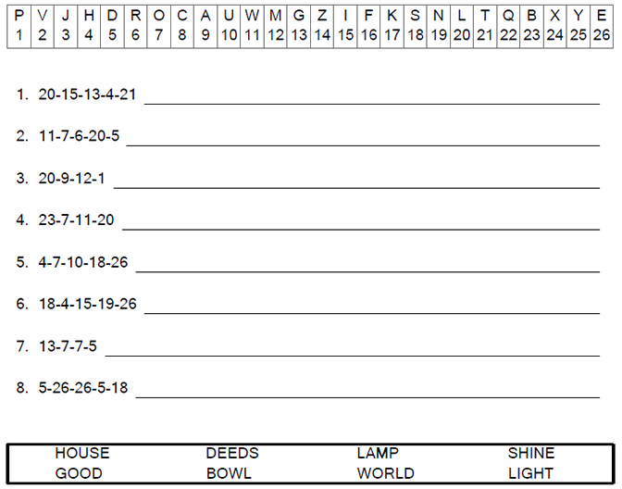

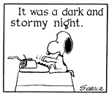

Coloring Page



Let your light so shine before men, that they may see your
good works, and glorify your Father which is in heaven.
Matthew 5:16

