Crossword Puzzle

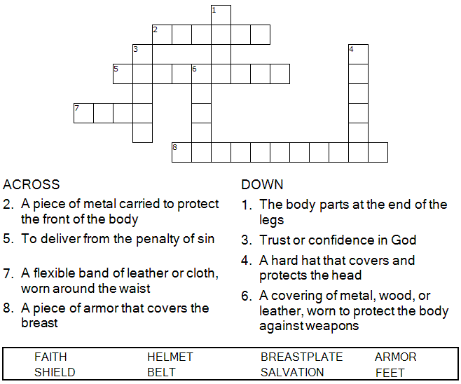

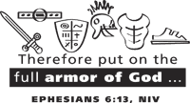

Copyright © Sermons4Kids, Inc.
May be reproduced for Ministry Use

Children’s Worship Bulletin



Ephesians 6:11-17

Word Search Puzzle

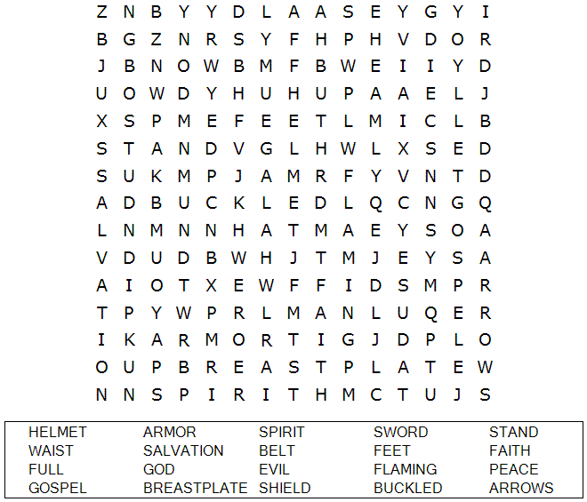

Your Church Name Here
Anytown, USA

Color Me

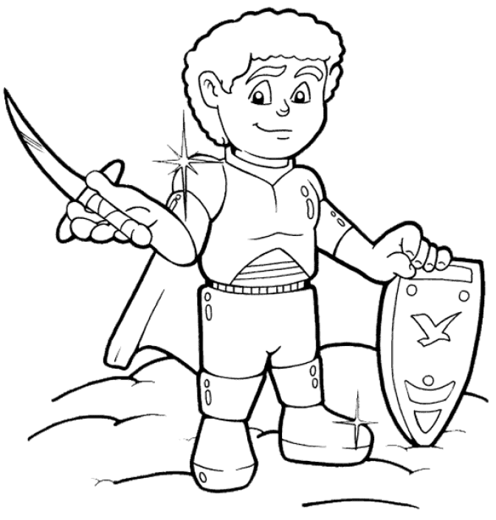

Put on the full armor of God so that you can
take your stand against the devil's schemes.
Ephesians 6:11

Copyright © CalvaryCurriculum.com
Used by Permission.

Decoder Puzzle
Each number represents a letter of the alphabet. Substitute the correct letter for the numbers to reveal the words.

