Crossword Puzzle

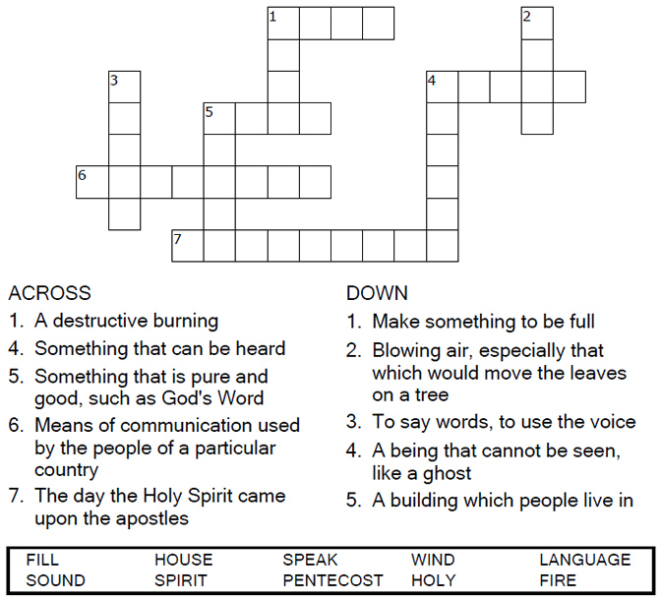


Copyright © Sermons4Kids, Inc.
May be reproduced for Ministry Use
Children’s Worship Bulletin



Acts 2:1-21

Word Search Puzzle

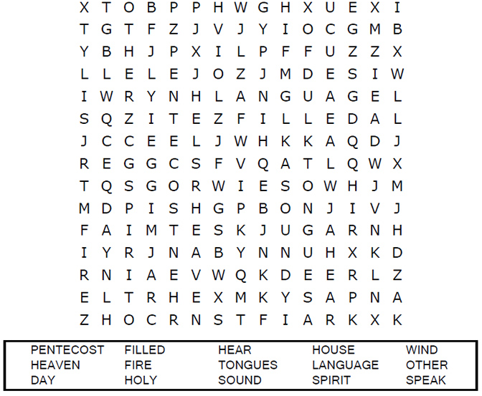
Your Church Name
Any Town, Anywhere

Coloring Page

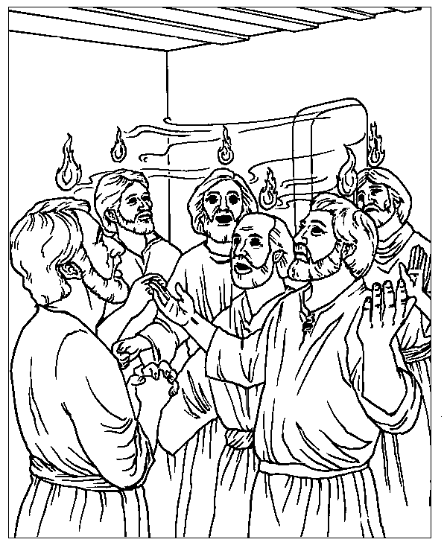
The Day of Pentecost
Acts 2

From Thru-the-Bible Coloring Pages for Ages 4-8. © 1986,1988 Standard Publishing.
Used by permission. Reproducible Coloring Books may be purchased from
Standard Publishing, www.standardpub.com, 1-800-323-5473.

Maze Puzzle

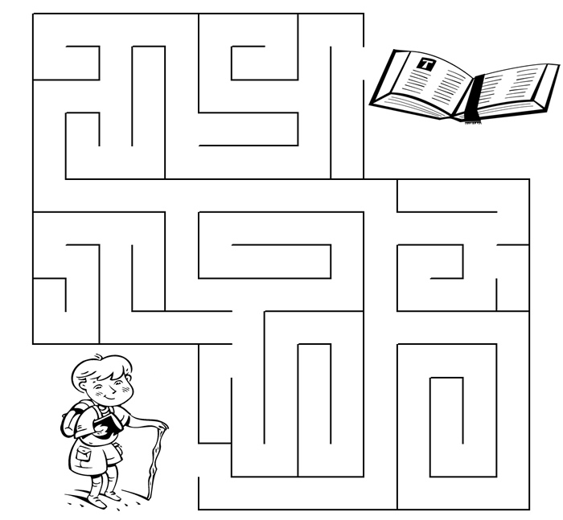

But when he, the Spirit of truth, comes,
he will guide you into all the truth.
John 16:13a (NIV)


