Crossword Puzzle

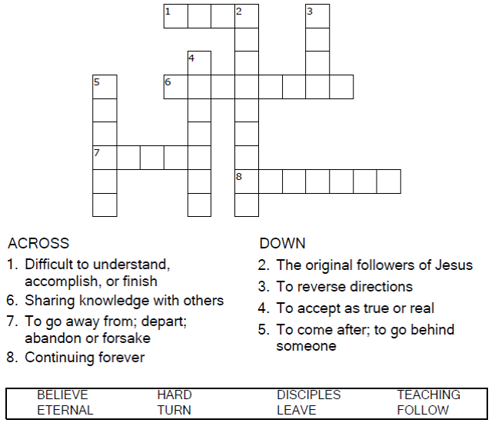


Copyright © Sermons4Kids, Inc.
May be reproduced for Ministry Use
Children’s Worship Bulletin



John 6:60-69

Word Search Puzzle

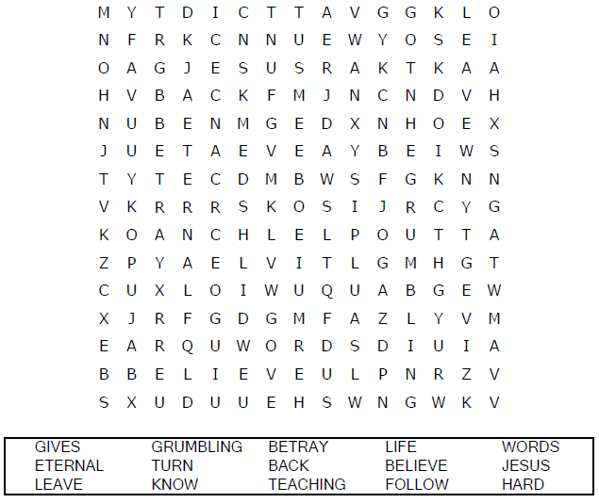
Church Name
Address
City

Coloring Page

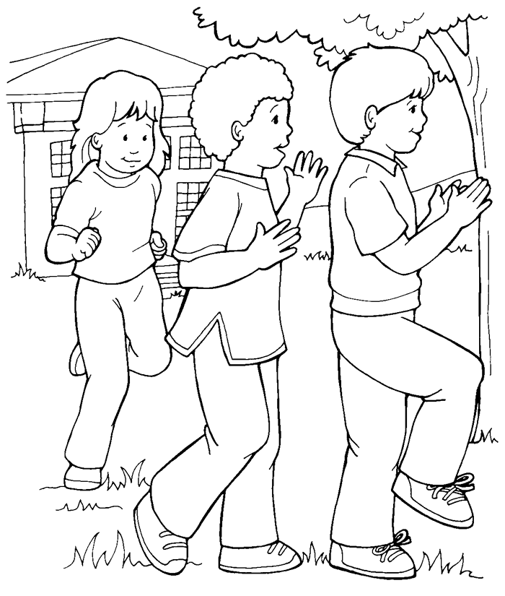
I will follow Jesus, our Leader.
From Thru-the-Bible Coloring Pages for Ages 4-8. © 1986,1988 Standard Publishing.
Used by permission. Reproducible Coloring Books may be purchased from
Standard Publishing, www.standardpub.com, 1-800-543-1301.

Maze Puzzle

Follow the path to Jesus!
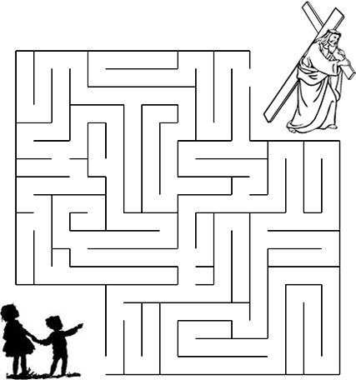

“You do not want to leave me too, do you?” Jesus asked
the Twelve. Simon Peter answered him, “Lord, to whom
whall we go? You have the words of eternal life.”
John 6:67-68 (NIV)

