Crossword Puzzle

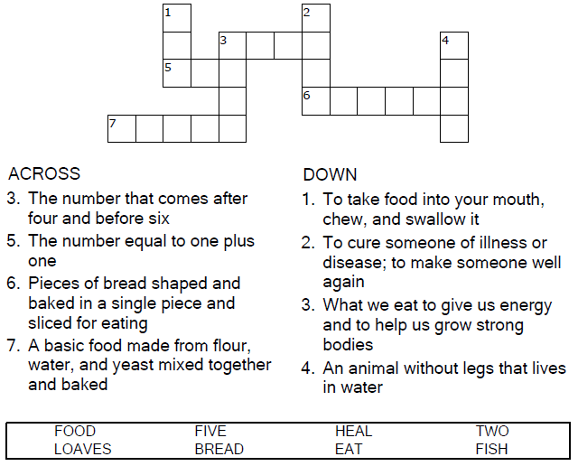


Copyright © Sermons4Kids, Inc.
May be reproduced for Ministry Use
Children’s Worship Bulletin



John 6:1-14

Word Search Puzzle

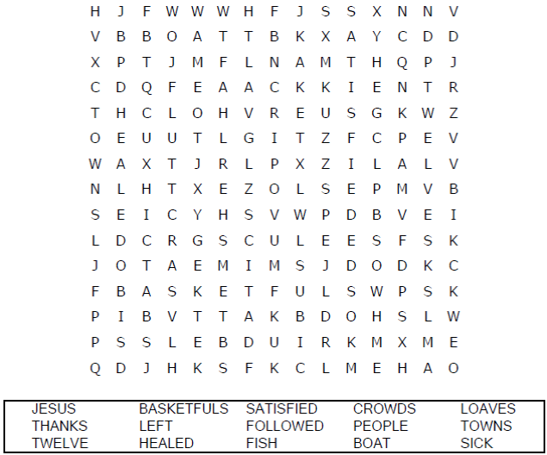

Your Church Name
Any Town, Anywhere

Coloring Page

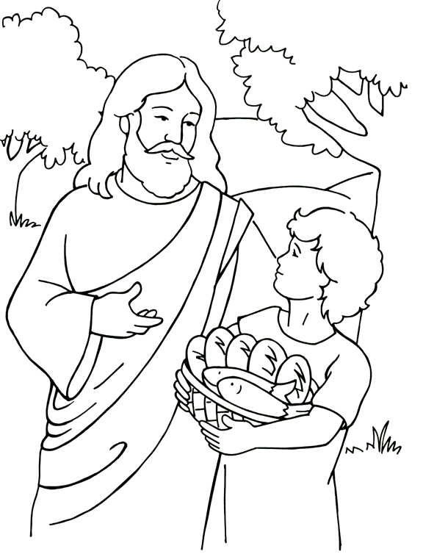
Jesus Feeds the 5000
From Thru-the-Bible Coloring Pages © 1986,1988 Standard Publishing.
Used by permission. Reproducible Coloring Books may be purchased
from Standard Publishing, www.standardpub.com, 1-800-323-7543.

Decoder
