Crossword Puzzle

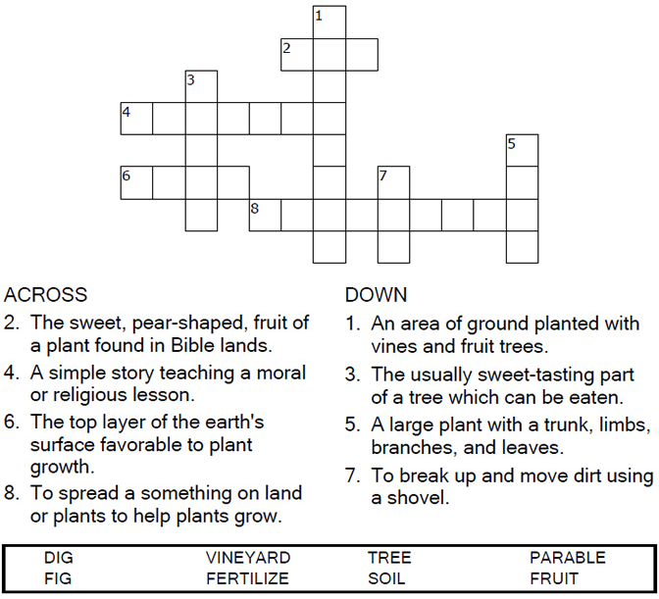

Copyright © Sermons4Kids, Inc.
May be reproduced for Ministry Use

Children’s Worship Bulletin



Luke 13:1-9

Word Search

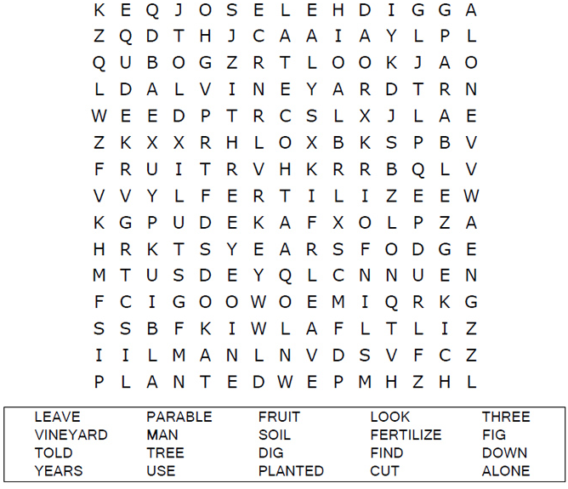
Your Church Name Here
Anytown, USA

Color Me!

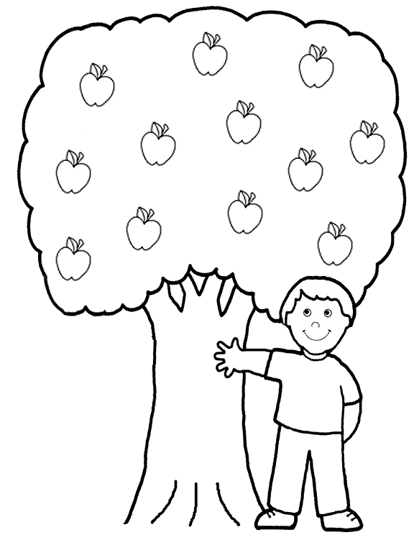
God wants us to bear good fruit!

Dot to Dot Puzzle
Connect the dots to complete the picture.
