Crossword Puzzle

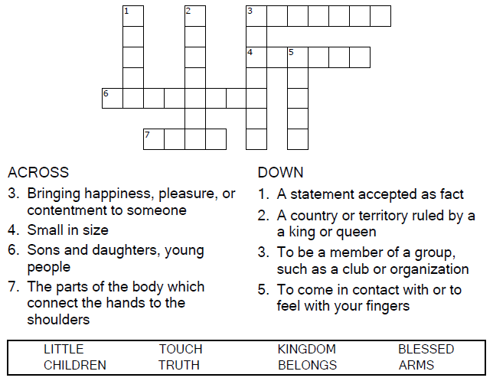
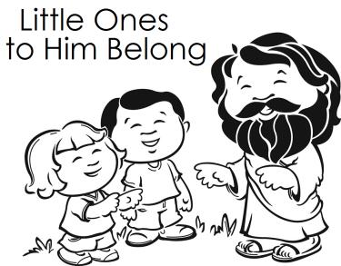

Copyright © Sermons4Kids, Inc.
May be reproduced for Ministry Use
Children’s Worship Bulletin



Mark 10:13-16

Word Search Puzzle

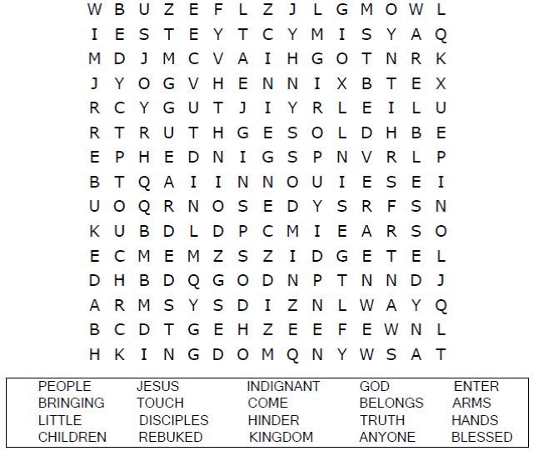
Church Name
Address
City

Coloring Page

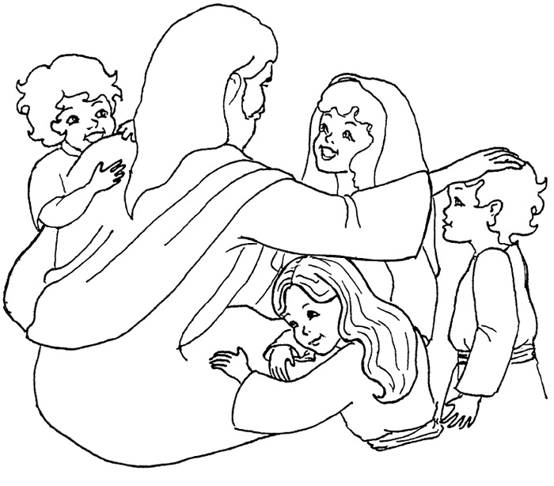

He said to them, “Let the little children come to me,
and do not hinder them, for the kingdom of God
belongs to such as these.
Mark 10:14

Copyright © CalvaryCurriculum.com
Used by Permission

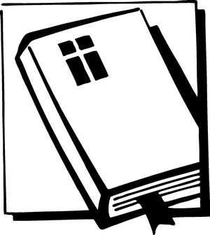

Matching Quiz

