Decoder Puzzle

Each number represents a letter of the alphabet.
Substitute the correct letter for the numbers
to reveal the coded words.

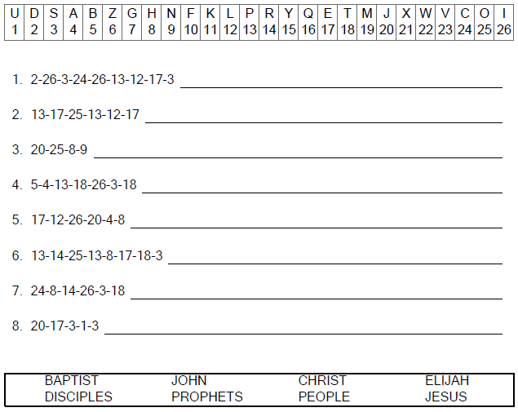
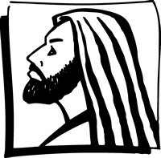

Copyright © Sermons4Kids, Inc.
May be reproduced for Ministry Use
Children’s Worship Bulletin



Mark 8:27-30

Word Search Puzzle

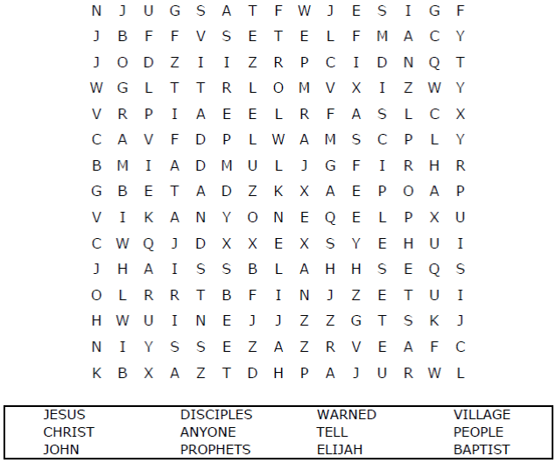
Church Name
Address
City

Coloring Page

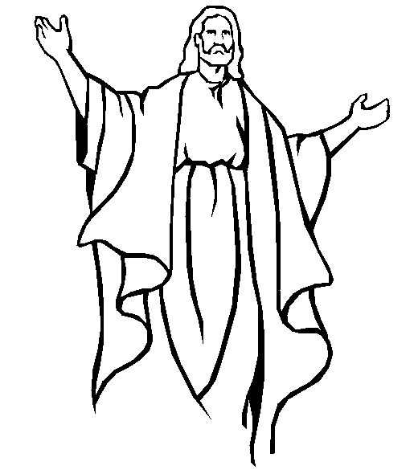

"But what about you?" he asked. “Who do
you say I am?" Peter answered,
"You are the Christ."
Mark 8:29

Fill in the Blanks

Choose the word that best completes the sentence.
(You can find the answers in Mark 8:27-34)

