Very early in the morning, while it was still dark, Jesus
got up, left the house and went off to a solitary place,
where he prayed.
Mark 1:35 (NIV)

Crossword Puzzle

Jesus Ministers in Galilee

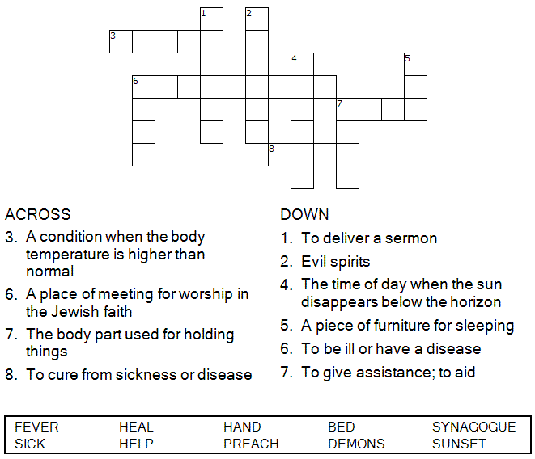

Copyright © Sermons4Kids, Inc.
May be reproduced for Ministry Use

Children’s Worship Bulletin



Mark 1:29-39

Word Search Puzzle

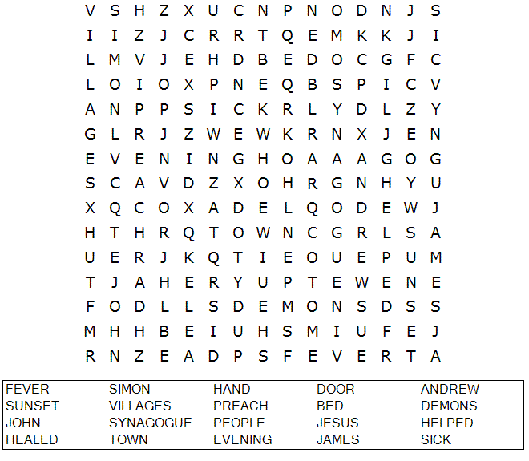
Your Church Name Here
Anytown, USA

Multiple Choice

Jesus Ministers in Galilee

Choose the word that best matches the definition.
Answers can be found in Mark 1:29-39 (NIV)

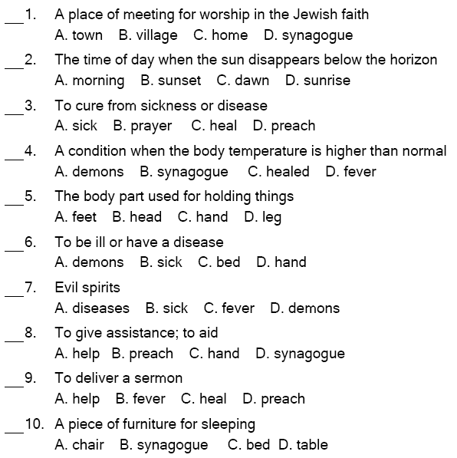

Jesus replied, "Let us go somewhere else—to the nearby villages—so I can preach there also. That is why I have come." Mark 1:38 (NIV)

Decoder Puzzle
Each number represents a letter of the alphabet. Substitute
the correct letter for the numbers to reveal the coded words.
