Crossword Puzzle
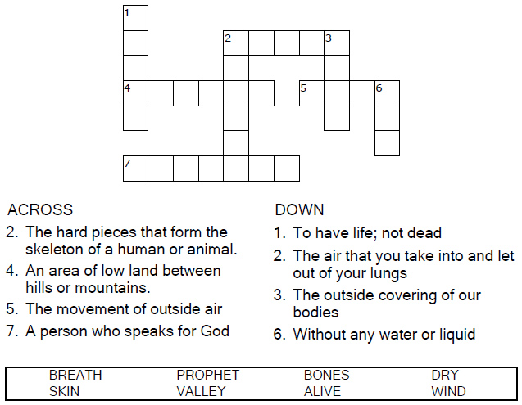
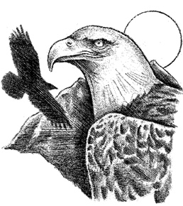
I will put breath in you and then
you will come to life.
Ezekiel 37:6

Copyright © Sermons4Kids, Inc.
May be reproduced for Ministry Use
Children’s Worship Bulletin



Ezekiel 37:1-14

Word Search

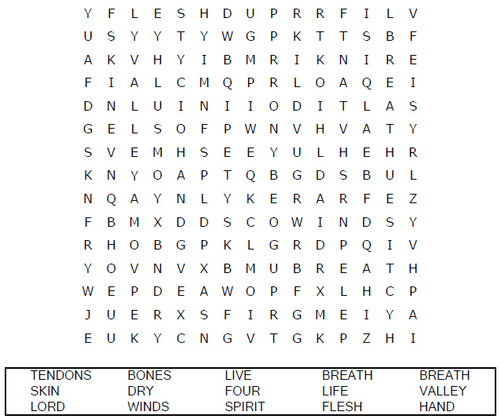
Your Church Name
City or Town

Decoder Puzzle
Each number represents a letter of the alphabet. Substitute
the correct letter for the numbers to reveal the coded words.
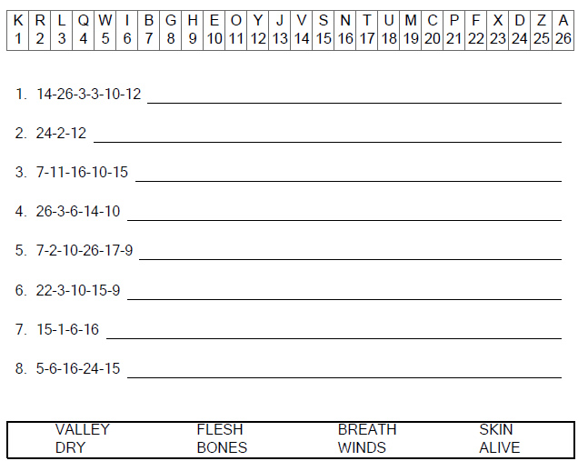

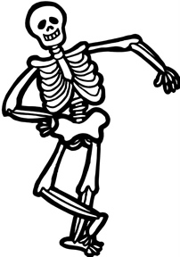

Coloring Page

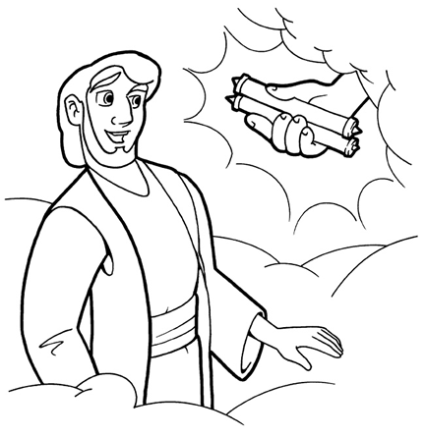
EZEKIEL’S CALL

Copyright © CalvaryCurriculm.com
Used by Permission

