Matching Quiz

Choose the word that best matches the definition.

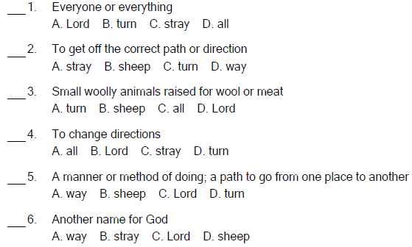
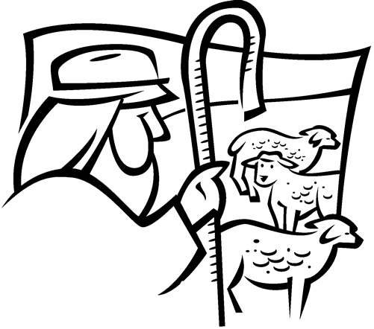

Copyright © Sermons4Kids, Inc.
May be reproduced for Ministry Use
Children’s Worship Bulletin



Isaiah 53:4-12

Word Search Puzzle

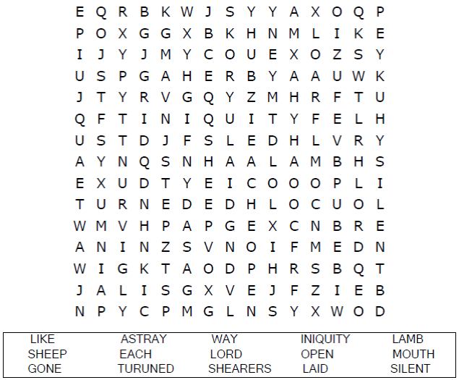
Church Name
Address
City

Coloring Page

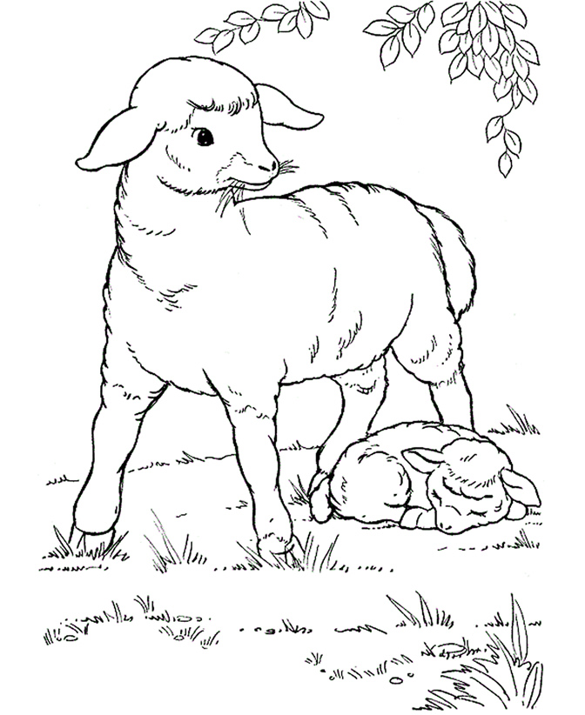
All We Like Sheep
Isaiah 53:6

Copyright © Coloring Pages for Kids
Used by Permission

Fill in the Blanks

Complete the Scripture verses by filling in the blanks with the
correct words from the word bank at the bottom of the page.
If you need some help, you can look it up in your Bible!

