Crossword Puzzle

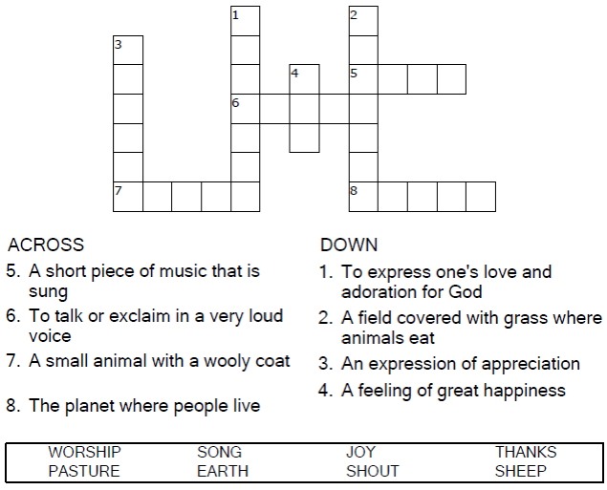


Copyright © Sermons4Kids, Inc.
May be reproduced for Ministry Use

Children’s Worship Bulletin



Psalm 100

Word Search Puzzle

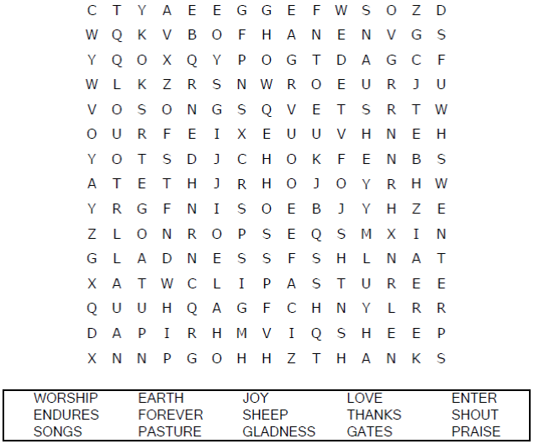
Church Name Here
Church Address
City

Coloring Page
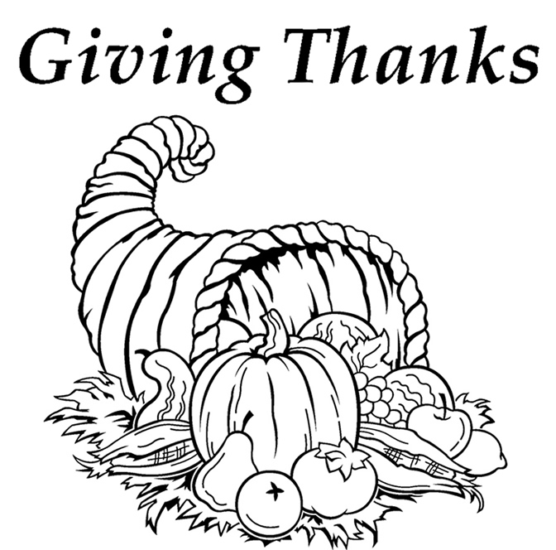

Enter his gates with thanksgiving and his courts with praise;
give thanks to him and praise his name.
Psalm 100:4



Decoder Puzzle

Each number represents a letter of the alphabet.
Substitute the correct letter for the numbers
to reveal the coded words.





