Crossword
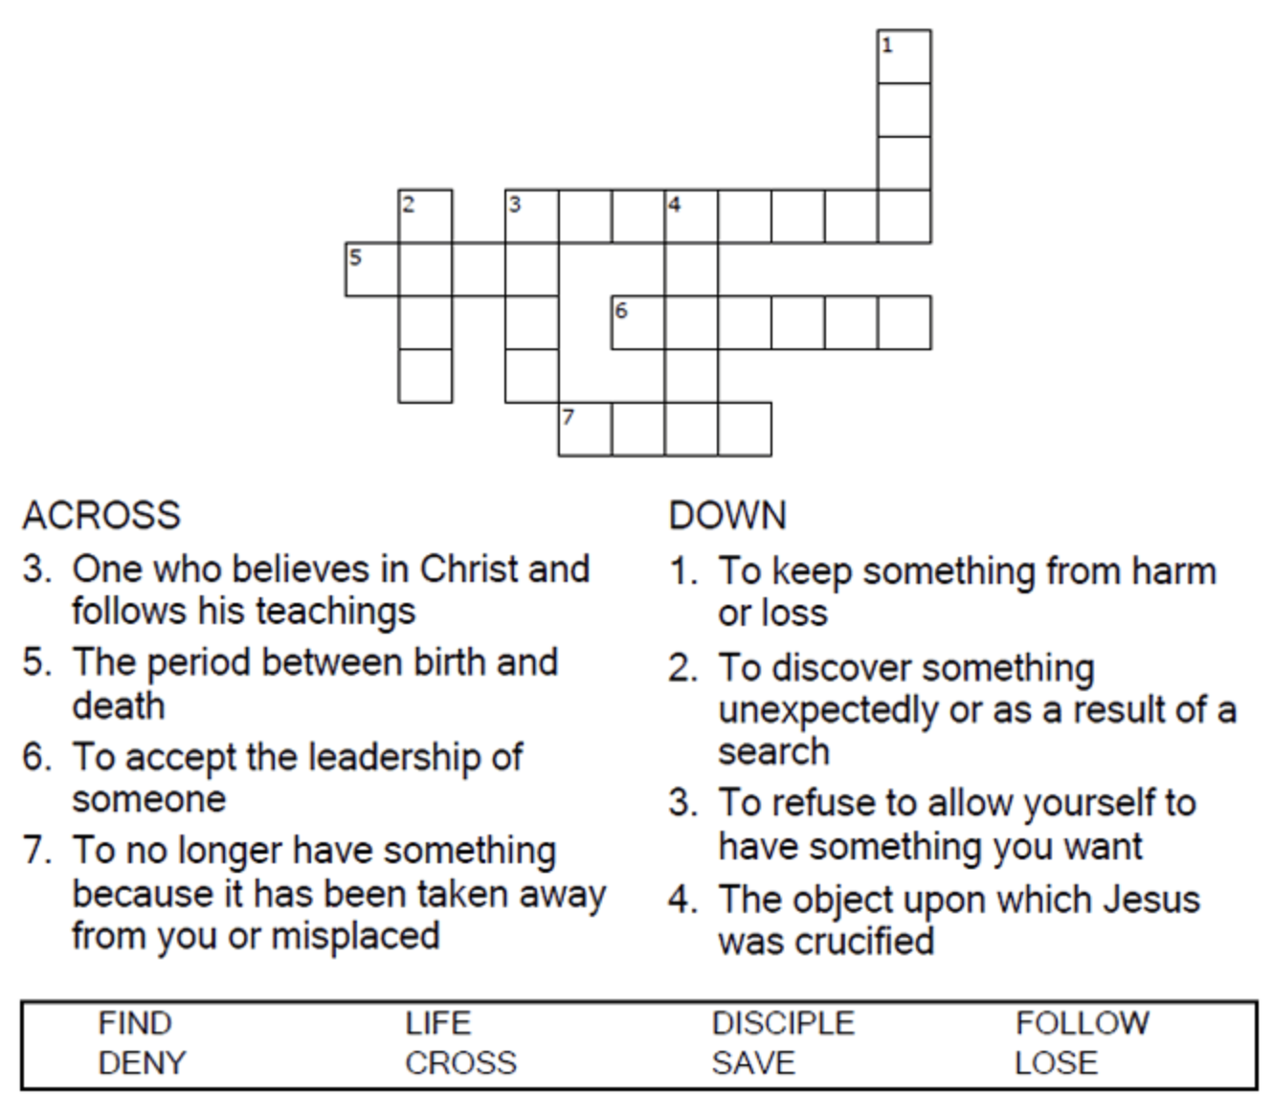

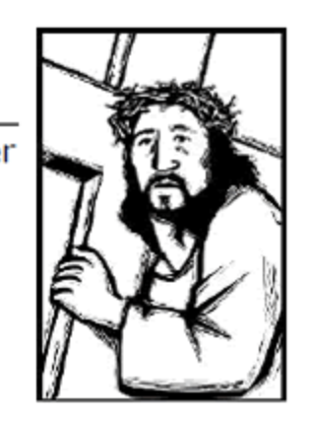

Copyright © Sermons4Kids, Inc.
May be reproduced for Ministry Use

Children’s Worship Bulletin

Following Jesus

Matthew 16:24-25

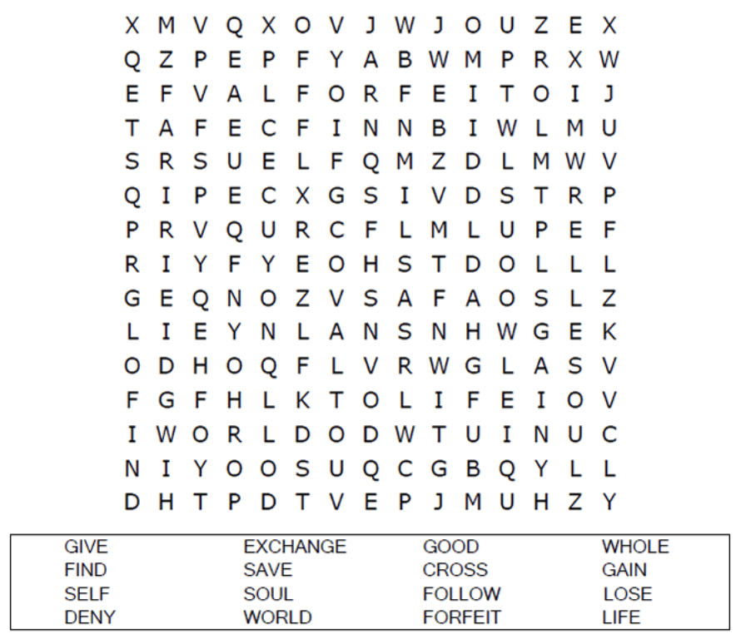
Your Church’s Name
Address
City, State

Coloring Page

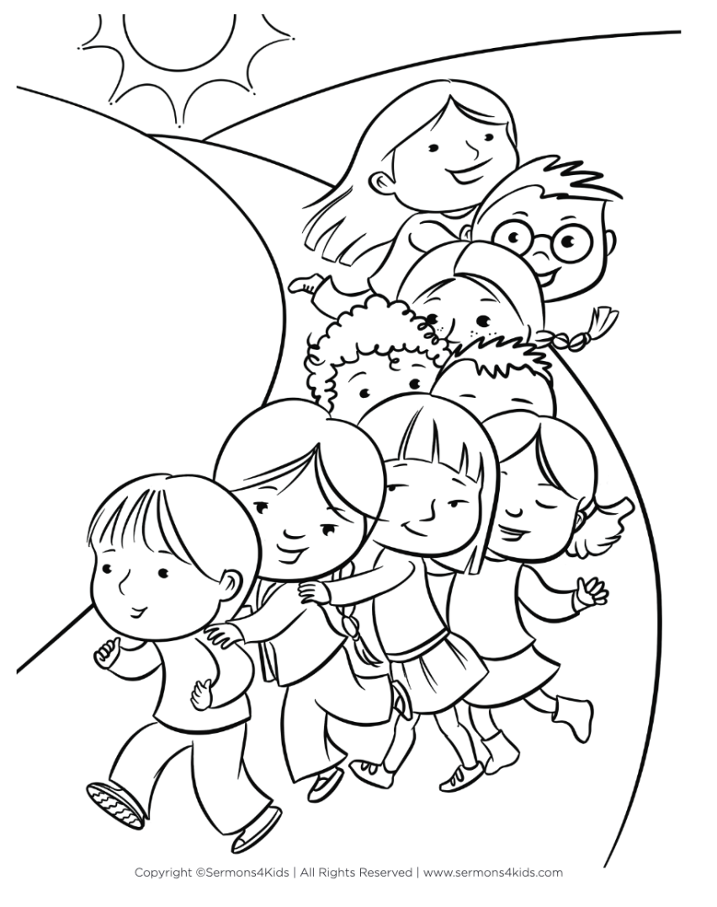

Decoder Puzzle
Complete the sentences by filling in the blanks with the correct words from the word bank at the bottom of the page,

